Misson
- Dread Pyrate
- Member

- 1,001 posts
- Gender:Male
- Interests:Who me?
(IP: 75.128.81.170) ·
Posted March 21, 2008 · Report post
Ooh...this is beautiful. An ivory handled surgical set. Apparently it was for show, according to the description on the website selling it.
http://antiquescientifica.com/surgical_set...e_full_open.jpg

- Quote
- Edit

Misson
- Dread Pyrate
- Member

- 1,001 posts
- Gender:Male
- Interests:Who me?
(IP: 75.128.81.170) · ·
Posted May 28, 2008 (edited) · Report post
The saw I covet: http://antiquescientifica.com/saw_amputati..._wb_overall.jpg
Edited November 17, 2009 by Mission

- Quote
- Edit
- Options

Misson
- Dread Pyrate
- Member

- 1,001 posts
- Gender:Male
- Interests:Who me?
(IP: 64.241.37.140) · ·
Posted July 12, 2008 (edited) · Report post
Ah. eBay is full of some fascinating medical things this week. More than I can afford this month. Here is my favorite, though (I'm just posting the pic because the auction will be over by the time you read this:

It's an 19th century apothecary weight set in a mahogony box with brass and bone tweezers for removing the smaller weights. Isn't it beautiful? Alas, it's post period and unnecessary for my Rx. (I'd almost be willing to buy it just to get those tweezers...but it's too expensive for that.)
Then there's this beautiful brass scale with four bone handled lancets. Alas, I already have a decent shell handled lancet that will serve and a more period correct scale - if I can ever find it.
Finally, for all you folks in Wisconsin (Duchess, Mary ) there's this fine objet d'art. Pretty affordable, esp. with the box included. (Everyone should have one.)
Edited July 12, 2008 by Misson

- Quote
- Edit
- Options

Misson
- Dread Pyrate
- Member

- 1,001 posts
- Gender:Male
- Interests:Who me?
(IP: 24.231.217.242) · ·
Posted July 23, 2008 (edited) · Report post
Here's some interesting surgical stuff from eBay.
This first one is a syphilitic syringe, used exclusively on the guys, which was inserted in...a very uncomfortable place. Like the frontseat of a Volkswagen. I think it will fetch over $100 or I'd post it after bidding. Geez. Look at the tip on the end of that thing....ouch. (Ladies, you just can't even begin to imagine...)

I really want one of these to explain to the general public...oh the looks it would get...but they seem to be a bit pricey. It was used to inject Mercury. (Oh boy.) You can see more as long as the auction is up on eBay here.
And this second is much easier to look upon for the male population. It's a pocket surgical kit, also currently on eBay here. Since I was just babbling about pocket kits in Twill, I thought this might be instructional. It's not from period - about 150 - 200 years too late based on the auction description (the clasp is a dead giveaway). However, I've been studying Woodall's sketch of the instruments from his 1639 edition of the Surgeon's Mate and these instruments may not actually be from period, but most of them were made roughly the same way and with the same materials. (Not the suction tube; that's dead wrong. The forceps and scissor tissue holders aren't really totally cricket either (although both existed during period), but you could probably get away with them.)

It's a beautiful kit; better than I've seen elsewhere so far. My guess is that this will probably fetch about $200+. The auction gives splendid descriptions of the tools, so I am copying that here for reference. I numbered the tools and am matching them to the best of my so far acquired ability vis-a-vis period surgical devices. (If anyone spots a mistake, feel free to let me know. I'm forever learning.)

Quote
1. heavy forceps - stamped 'Pradat'
2. Large folding (9 1/2" open) sharp suture feeder (modern equivalent = aneurysm needle) - stamped 'Pradat'
3. Folding (7" when fully open) dual nerve/tissue hooks, 1 blunt ended, 1 sharp ended - stamped 'Pradat'
4. Fine folding locking (6 1/2" when open & locked) surgical scalpel - stamped 'Lardeux'
5. Fine folding locking (6" when open & locked) surgical scalpel - stamped 'Collin & CIE'
6. Heavy folding locking (7" when open & locked) scalpel - stamped 'Pradat'
7. Heavy folding locking (6 3/4" when open & locked) scalpel - stamped 'Pradat'
8 & 9. A pair of horn handled steel ?retractors - stamped 'Pradat'
10. A pair of steel non-locking scissor mechanism tissue holders - 6 3/4" long - not marked with makers name
11. Silver plated metal suction tube - 6 1/4" long - not marked with makers name
12. Heavy & blunt-nosed folding locking (7" when open & locked) scalpel - stamped 'Pradat'
13. Wooden handled sharp needle/probe - 5 1/2" long - unmarked
14, 15 & 16. A set of three complementing large solid surgical scalpels, horn handled steel, each has a curved or bowed blade, with a Right blade, a Left blade and a blade sharp on both sides.
Edited July 23, 2008 by Misson

- Quote
- Edit
- Options

Capt. Sterling
- Sticky Fingers Sterling Needs a New Hat
- Member

- 10,302 posts
- Gender:Pyrate Hunter
- Location:here
- Interests:Killing pirates, haven't met one yet worth keeping alive....
(IP: 76.4.91.168) · ·
Posted July 23, 2008 · Report post
Misson said:
Here's some interesting surgical stuff from eBay.
This first one is a syphilitic syringe, used exclusively on the guys, which was inserted in...a very uncomfortable place. Like the frontseat of a Volkswagen. I think it will fetch over $100 or I'd post it after bidding. Geez. Look at the tip on the end of that thing....ouch. (Ladies, you just can't even begin to imagine...)

Damnation!

- Quote
- Edit
- Options

Mission
- Goat Specialist
- Admin

- 5,082 posts
- Gender:Male
- Location:Monroe, MI
- Interests:Scholarly piracy, designing and creating haunted house rooms and props, movies, abstract thinking, abstruse thinking, obstructive thinking, ideating, random thinking, movies, cartoons, movies, movies scores, cycling, world peace and small furry dogs, movies, writing, drawing, personal skills training, gremlins and, of course, lest I forget, movies.
(IP: 24.231.217.242) · ·
Posted June 7, 2009 (edited) · Report post
vintage sailor sent me an email with a question that I thought I would post for everyone (mainly because I cannot completely and succinctly answer it and someone else may have some valuable insight.)
vintagesailor said:
I was wondering if you might have any information regarding in short early tweezers. I am looking for something about 5 inches long a single piece of steel bent in the middle and pointed on both ends. To me it looks like something that might be used to extract a bullet. Do you have any pictures of anything like that?
Tweezers would be too small to remove bullets - a surgeon would most likely have used forceps or his fingers for that job. However, he might have had tweezers for the same reason we have them today - to extract slivers of material. (In fact, splinters from cannon balls striking shipboard were far more likely to kill a sailor than the cannon ball itself.) Surgeons might also used them in an apothecary capacity - to measure out quantities of material for making medicines. I have something like this in my apothecary toolkit, although it is almost surely post-period. Unfortunately, I don't have a photo of it - I will get one and post it when I do. The ones I have are Scandanavian - made of black iron, forged and about 6" or 7" long. The top is bent in a circle like C below.
The one photo I did find in my gathered material is from the wonderful, excellent, outstanding and obviously highly recommended The Evolution of Surgical Instruments; An Illustrated History from Ancient Time to the Twentieth Century by John Kirkup. This is scanned in from page 215:

Notice how fancy these things are? It was not uncommon for items to have decorative flourishes like the ones shown in the photo. In fact, the earlier a surgical item is, the more decoration it is likely to have from what I've read. During the 17th century, manufacturers were moving away from the decorative touches as they sometimes got in the way of the surgery. However, personal items probably would have been more likely to have such touches if I understand it correctly.
Some notes on all surgical instruments and tools - they did not plate metal at this point, so anything plated is post-period. They did not have stainless steel, so that's out as well. A surgeon might have had a pair made of steel, brass or silver. A common sea-surgeon probably would not spend the extra money for silver, however, as they were pretty low on the pay scale.
Tweezers could be used as personal hygiene items as well - kind of like they are today. I have seen such items on eBay, but I've found the dating of items there is often very dodgy. If they came from a personal kit, my thought would be that they would belong to a upper class person (as opposed to a regular sailor).
Edited June 8, 2009 by Mission

- Quote
- Edit
- Options

Mission
- Goat Specialist
- Admin

- 5,082 posts
- Gender:Male
- Location:Monroe, MI
- Interests:Scholarly piracy, designing and creating haunted house rooms and props, movies, abstract thinking, abstruse thinking, obstructive thinking, ideating, random thinking, movies, cartoons, movies, movies scores, cycling, world peace and small furry dogs, movies, writing, drawing, personal skills training, gremlins and, of course, lest I forget, movies.
(IP: 24.231.217.242) · ·
Posted June 8, 2009 (edited) · Report post
Here are my apothecary tools. The last one is a pair of tweezers. I believe they are at least 50-100 years out of period, but they look pretty correct so they work for me. (Truth is, they're not very interesting to most people so I don't even talk about them. They're just window dressing.)

Edited June 8, 2009 by Mission

- Quote
- Edit
- Options

Mission
- Goat Specialist
- Admin

- 5,082 posts
- Gender:Male
- Location:Monroe, MI
- Interests:Scholarly piracy, designing and creating haunted house rooms and props, movies, abstract thinking, abstruse thinking, obstructive thinking, ideating, random thinking, movies, cartoons, movies, movies scores, cycling, world peace and small furry dogs, movies, writing, drawing, personal skills training, gremlins and, of course, lest I forget, movies.
(IP: 64.241.37.140) · ·
Posted November 7, 2009 (edited) · Report post
Boy, the things you find hanging around eBay. This is an 18th century (according to the eBayer) spring-loaded fleam. It looks pretty right for period to me, but I'm no expert. Very, very cool, although the auction beginning price is insane. So I'll just share the pictures so you folks can admire this thing too. (A fleam is used for bloodletting. The blades during period were usually driven in with a wooden stick, although some fancier encased mechanical spring-loaded fleams were starting to appear near the end of the GAoP):

The auction description yells:
"RARE 18TH CENTURY STEEL FLEAM IN LOVELY CONDITION .THERE IS A COMPARTMENT FOR SPARE BLADES. TWO BLADES ARE PRESENT. LENGTH 4 INCHES. SOME PITTING AS IN IMAGES.."
They had a thing for using multiple blades, probably to make different cuts, although on my (non-spring loaded) multi-bladed fleem, the blades are very similar.
Edited November 7, 2009 by Mission

- Quote
- Edit
- Options

Mission
- Goat Specialist
- Admin

- 5,082 posts
- Gender:Male
- Location:Monroe, MI
- Interests:Scholarly piracy, designing and creating haunted house rooms and props, movies, abstract thinking, abstruse thinking, obstructive thinking, ideating, random thinking, movies, cartoons, movies, movies scores, cycling, world peace and small furry dogs, movies, writing, drawing, personal skills training, gremlins and, of course, lest I forget, movies.
(IP: 24.231.221.86) · ·
Posted November 9, 2009 · Report post
Here's a fine dental pelican from an eBay auction that the seller took down for some reason. (I really wanted to bid on this, although the price had already gotten too high for me by the time he closed it.) The seller explains:
"Antique dental pelican, 1600's
An exceptional early dental pelican from 1600's, all wrought iron, in perfect condition with its original patina, great design and an engraved elicoidal decorative line on the shaft.
Lenght: 14.5 cm"

I would actually be interested in having one of these made. My guess is that it was originally sandcast and hand filed and drilled.

- Quote
- Edit
- Options

Mission
- Goat Specialist
- Admin

- 5,082 posts
- Gender:Male
- Location:Monroe, MI
- Interests:Scholarly piracy, designing and creating haunted house rooms and props, movies, abstract thinking, abstruse thinking, obstructive thinking, ideating, random thinking, movies, cartoons, movies, movies scores, cycling, world peace and small furry dogs, movies, writing, drawing, personal skills training, gremlins and, of course, lest I forget, movies.
(IP: 64.241.37.140) · ·
Posted November 14, 2009 (edited) · Report post
Now here's something fun to have around the house for when the kids get bored.

It's a little past period and I doubt any seaman would bothered to invest in one anyhow, but I thought I'd post it here in keeping with my theme. It's up for auction on eBay for you do-it-yourselfers.
Edited November 14, 2009 by Mission

- Quote
- Edit
- Options

Mission
- Goat Specialist
- Admin

- 5,082 posts
- Gender:Male
- Location:Monroe, MI
- Interests:Scholarly piracy, designing and creating haunted house rooms and props, movies, abstract thinking, abstruse thinking, obstructive thinking, ideating, random thinking, movies, cartoons, movies, movies scores, cycling, world peace and small furry dogs, movies, writing, drawing, personal skills training, gremlins and, of course, lest I forget, movies.
(IP: 24.231.221.86) · ·
Posted November 24, 2009 · Report post
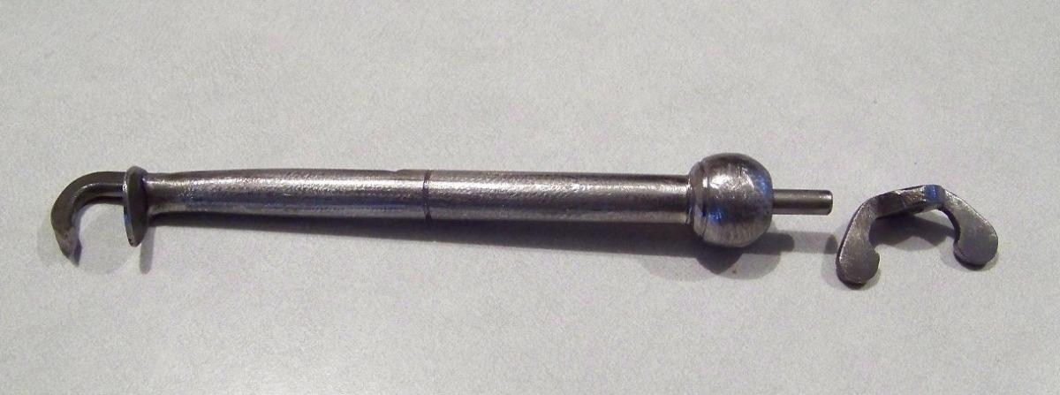
Oh boy, oh boy, oh boy! My pelican is almost done! I hope I can get it to PiP with me on the plane! Isn't she beautiful? Good ol' Etsy! I'll have almost everything needed to start doing period dental work! Any takers?

- Quote
- Edit
- Options

Mary Diamond
- It's My Fault
- Moderator

- 1,050 posts
- Gender:Female
- Location:Illinois
- Interests:Things I Love: Horticulture, Travel, Volleyball, Reading, Sewing, Costuming, Halloween, esp. props!, Halo, Halo2, Halo3, ODST, and, of course, Pyracy.
(IP: 24.13.221.117) · ·
Posted November 24, 2009 · Report post
Bored kids shooting themselves in the eye ~ Honey, how did your eyes get all infected? Eeeewww.
Love the new pelican ~

- Quote
- Edit
- Options

Mission
- Goat Specialist
- Admin

- 5,082 posts
- Gender:Male
- Location:Monroe, MI
- Interests:Scholarly piracy, designing and creating haunted house rooms and props, movies, abstract thinking, abstruse thinking, obstructive thinking, ideating, random thinking, movies, cartoons, movies, movies scores, cycling, world peace and small furry dogs, movies, writing, drawing, personal skills training, gremlins and, of course, lest I forget, movies.
(IP: 12.167.152.34) · ·
Posted November 25, 2009 (edited) · Report post
Shooting themselves in the eye...? Methinks thou dost not fully grasp the function of said device, milady.
Ok, it is finished, although this is just the blacksmith's photo; I do not yet have the device in hand. However, since I drew it up for him in Autocad and he followed my drawing, I feel pretty confident in the final product. My new blacksmith friend is quite proud of his work, so I believe it is good stuff. However, the final verdict will be when I have it in hand and try it out on my cat. (How many teeth does a cat need, really?)

As to the use of this device, let me quote Alexander Munro, who explained its use in 1742.
"'When this instrument is used, the claw [top of the device] is put inside of the tooth to be drawn with its points as near to the roots of the tooth as they can conveniently be put. The end of the rest [the inside of the 'claw'] is placed on the outside of the gums and a finger being placed above the claw to keep it from slipping, the patient's head is held by the surgeon, who pressed down the handle to extract the tooth, by raising the tooth, moved in an arch of a circle from the socket."
Isn't that lovely? Hmm?
(PS. Just kidding about the cat. Dogs maybe, but cats...no. Dogs have bigger teeth.)
(No, kidding again! Don't sic (heh) the ASPCA on me. I don't even own a dog. Maybe the neighbors do, but what of that? I mean, seriously. So he goes missing a few teeth...it has nothing to do with me.)
Edited November 27, 2009 by Mission

- Quote
- Edit
- Options

Mary Diamond
- It's My Fault
- Moderator

- 1,050 posts
- Gender:Female
- Location:Illinois
- Interests:Things I Love: Horticulture, Travel, Volleyball, Reading, Sewing, Costuming, Halloween, esp. props!, Halo, Halo2, Halo3, ODST, and, of course, Pyracy.
(IP: 24.13.221.117) · ·
Posted November 27, 2009 · Report post
On 11/25/2009 at 9:42 PM, Mission said:
Shooting themselves in the eye...? Methinks thou dost not fully grasp the function of said device, milady.
Function surmised, however, I cannot say the same understanding will dawn on a child. I most certainly hope they would not know what it is!

- Quote
- Edit
- Options

Mission
- Goat Specialist
- Admin

- 5,082 posts
- Gender:Male
- Location:Monroe, MI
- Interests:Scholarly piracy, designing and creating haunted house rooms and props, movies, abstract thinking, abstruse thinking, obstructive thinking, ideating, random thinking, movies, cartoons, movies, movies scores, cycling, world peace and small furry dogs, movies, writing, drawing, personal skills training, gremlins and, of course, lest I forget, movies.
(IP: 24.231.221.86) · ·
Posted January 11, 2010 (edited) · Report post
I've asked my blacksmith friend to make a spatula mundani for me. (It's a tool designed by John Woodall himself.) Fortunately, there is one at the Jamestown website that I was able to use to make a technical drawing from. Woodall actually shows several in the surgion's mate (1639), so I may have him make me two different styles.
Next on my list of drawings is the Woodall Bonesaw....yessss. We wants it, we needs it. Must have the precious...
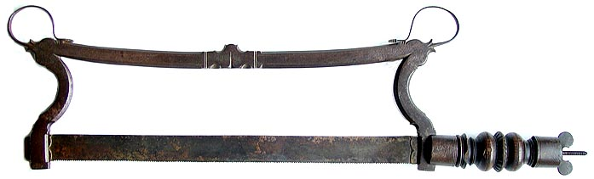
Edited January 12, 2010 by Mission

- Quote
- Edit
- Options

Patrick Hand
- The sailor's sailor
- Moderator

- 6,100 posts
- Gender:Male
- Location:TH' Mountains of Central California
- Interests:I like wierdness... Klingon, Pyrate..... and even..... gasp.... Renn Faires...... (Baseball and tractor pulls I'd have to think about.... could be wierd or Not,,,,)
(IP: 98.224.0.63) · ·
Posted January 12, 2010 · Report post
Dang... here I be droolin' over things wot put nice messy holes and tears into people... an' yer droolin' over things to patch them up (or inject curative elixirs (wot ever) inter people.....)

- Quote
- Edit
- Options

Sjöröveren
- Plunderer
- Member

- 457 posts
- Location:Minnesota, Land of 10,000 Lakes and 1 mini-ocean
- Interests:Re-enactment, gradually working my way back from the 19th Century. I figure I'm in about 1700 right now. I specialize in the history of medicine. I like maps, and the general history of geography and geodesy. <br />And in case you're wondering, "Sjöröveren" is Swedish for "the sea rover." And it's supposed to be spelled "Sjörövaren" but I guess it's too late for that!
(IP: 64.131.3.142) · ·
Posted January 13, 2010 · Report post
On 11/14/2009 at 9:25 AM, Mission said:
Now here's something fun to have around the house for when the kids get bored.

It's a little past period and I doubt any seaman would bothered to invest in one anyhow, but I thought I'd post it here in keeping with my theme. It's up for auction on eBay for you do-it-yourselfers.
"All that Clysters is not Gold"
This is the second "auto-clyster" that I have seen on ebay recently. The other was mid to late 19th Century, if I recall correctly.
Love that fleam! I've never seen quite that design before. I had a blacksmith make a similar one for me, but he didn't understand the spiraling, and made it a tight spiral of of several turns rather than a gentle scroll like this one. And it took him several years to do it. Time to find another blacksmith, I think.

- Quote
- Edit
- Options

Mission
- Goat Specialist
- Admin

- 5,082 posts
- Gender:Male
- Location:Monroe, MI
- Interests:Scholarly piracy, designing and creating haunted house rooms and props, movies, abstract thinking, abstruse thinking, obstructive thinking, ideating, random thinking, movies, cartoons, movies, movies scores, cycling, world peace and small furry dogs, movies, writing, drawing, personal skills training, gremlins and, of course, lest I forget, movies.
(IP: 24.231.221.86) · ·
Posted January 13, 2010 (edited) · Report post
I was reading a book on ancient dental instruments (by Frank Colver - highly recommended if period dental instruments interest you) and there are more different designs for the dental pelican than you'd probably believe. I think I scanned in over 50 photos and drawings of period or near-period designs. There were at least that many more than that from post-period. (Godwin's website has it wrong when they say that surgeons switched from the pelican to the toothkey after the latter was invented in the mid 18th century. They were still designing new pelicans in the early 19th century.)
I recommend the guy who made that (his name is Zach, the Etsy site is in his wife's name.)
http://www.etsy.com/shop/jenniferannmurphy
He has my Acad drawing for that thing, so if you like it, he'll be more than happy to make you one, I'm sure. Ditto the Spatula Mundani. I just uploaded the drawing for him yesterday.
Edited January 13, 2010 by Mission

- Quote
- Edit
- Options

callenish gunner
- Scourge o' the 7 Seas
- Member

- 2,138 posts
- Gender:Male
- Location:Pennsylvania mountains north of Clarion
- Interests:The Callenish gunner has just hoved into view looking for safe anchorage in these waters... purveyor of bladed and flintlock weaponry also leather accessories ..........painter of portraits and period scenes by avocation I'm getting my armoury business underway and will be doing as many festivals as I can ...right now along the east coast or great lakes
(IP: 98.21.88.5) · ·
Posted January 13, 2010 · Report post
Isn't that one of those launchers for the water rockets ;) I haven't played with one of those in years, since my son Joshua was like 9-10 ;)

- Quote
- Edit
- Options

Mission
- Goat Specialist
- Admin

- 5,082 posts
- Gender:Male
- Location:Monroe, MI
- Interests:Scholarly piracy, designing and creating haunted house rooms and props, movies, abstract thinking, abstruse thinking, obstructive thinking, ideating, random thinking, movies, cartoons, movies, movies scores, cycling, world peace and small furry dogs, movies, writing, drawing, personal skills training, gremlins and, of course, lest I forget, movies.
(IP: 24.231.221.86) · ·
Posted January 19, 2010 · Report post
I saw this on an eBay auction and thought it was kind of nice. It didn't sell at $685, so you could probably still email the seller and buy it. (If you're made of money, that is.) It looks sort of fancy for a workman's set which makes me wonder if this isn't a show set of some kind. I recall seeing another set of white instruments that was described as being primarily for show. Although bone was one of the materials used to make instruments during period, so it could be a regular set. Neat instruments.
Here's the description:
"This is a 1700s Dentist Scaling Tool set in leather covered wood case. There are seven, 7, dental scraper tools inside leather box and in exceptional good condition. Tool handles are in "I" or Bone with a beautiful patina. These rare treasures were most often found with travelers in the 1700s to 1800s and often used by dentists of the period. The leather case is lined in red silk and also in very good condition (Small portion of leather is missing on bottom of case). Similar instruments can be found in the Bennion and Wilbur Books on Antique Dental Instruments. These seldom found treasures date from late 1700s and most likely Italy. Each scalar is 3.75” in length. Case size is 4 x 3.5 x .50 inches."

- Quote
- Edit
- Options

Mary Diamond
- It's My Fault
- Moderator

- 1,050 posts
- Gender:Female
- Location:Illinois
- Interests:Things I Love: Horticulture, Travel, Volleyball, Reading, Sewing, Costuming, Halloween, esp. props!, Halo, Halo2, Halo3, ODST, and, of course, Pyracy.
(IP: 24.13.221.117) · ·
Posted January 22, 2010 · Report post
Another beautiful set ~ love the detail around the ferrule.

- Quote
- Edit
- Options

Mission
- Goat Specialist
- Admin

- 5,082 posts
- Gender:Male
- Location:Monroe, MI
- Interests:Scholarly piracy, designing and creating haunted house rooms and props, movies, abstract thinking, abstruse thinking, obstructive thinking, ideating, random thinking, movies, cartoons, movies, movies scores, cycling, world peace and small furry dogs, movies, writing, drawing, personal skills training, gremlins and, of course, lest I forget, movies.
(IP: 24.247.94.112) · ·
Posted May 5, 2012 (edited) · Report post
It's been awhile since I did one of these, but I found this nice small trepanning set up for auction on eBay and I thought I'd do my best to share the details of it for those of you with $2K to spend on such a lovely set. (Plus I just felt like doing this.) This may or may not be a GAoP-era set, but I think it's reasonably close if it isn't. I'd guess it not being much newer than 1760s or 70s in any case. (But I am guessing.)
The auction reads:
"We are offering a fine 18th-century trepanning set in its original fish skin covered case. One instrument is missing and the scalpel is an early-19th-century replacement but o/w this set is in vg condition noting that the exterior wooden base of the case has a crack running across it--the case remains completetly tight and sound."
Below is the fish skin covered case. Look at those hinges and that handle! Good stuff.
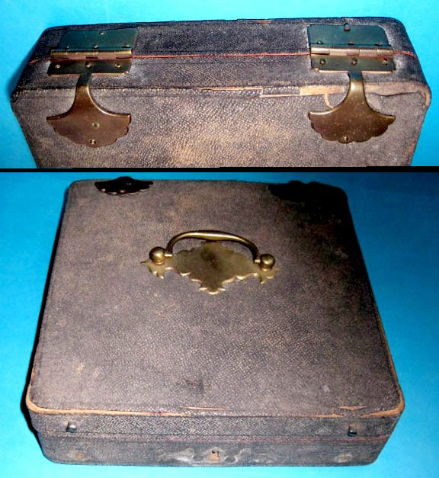
And here is the set of trepanning instruments inside the case. The letters are to compare this image with the ones following. I will detail the instruments that latter photos.
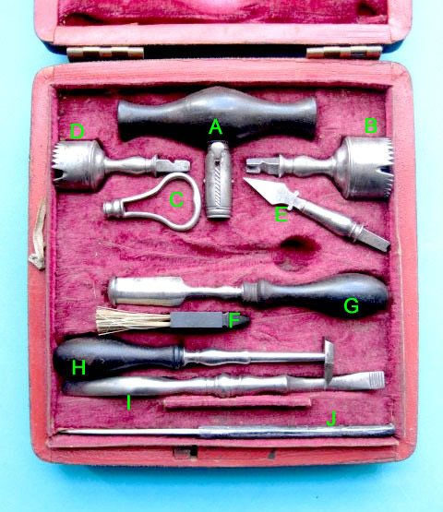
The Trepanning equipment:
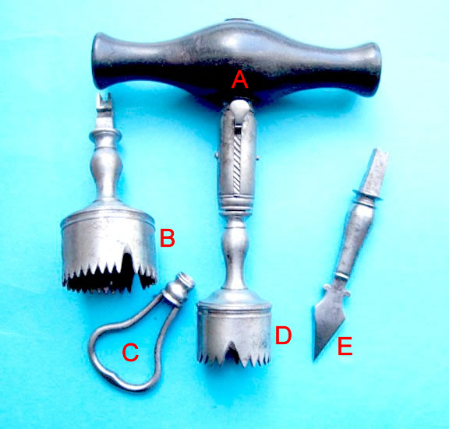
A ) The Trepan Handle - used to hold the three Cutting Heads.
B ) The Large Trepan Cutting Head - part of the reason I know these are earlier era trepans is because the cutting tools have no way to stop them from going in too far. Later-era tools were either tapered - 'Galt' style - or had lips - crown style - to stop them from going in too far and damaging the brain.
C ) A Key - used to remove the guiding point that is located inside the two round cutting heads. The point would be driven into the skull until the teeth of the round cutting heads started to bite into the skull and then this key would be used to remove the point so that it didn't damage the brain as the teeth of the round cutting heads did their work.
D ) The Medium Trepan Cutting Head. If you look in the large triangular gap, you can see the guiding point inside the tool.
E ) A Spade-Shaped Cutting Tool. This could be used to make an indentation in the bony skull to guide the point located in the round cutting heads.
The ancillary instruments used during a trepanation:
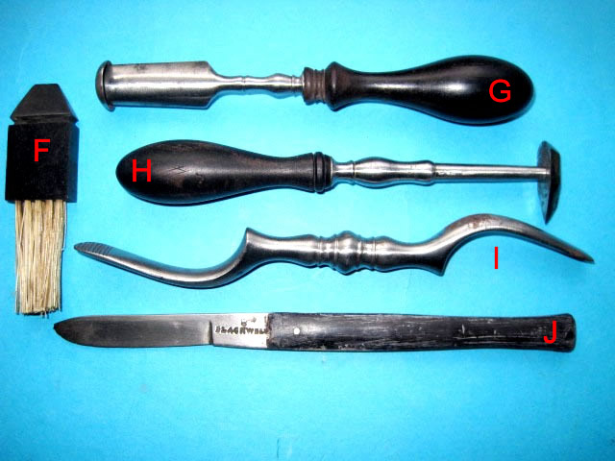
F ) The Bone Dust Brush used to whisk away bone dust during the operation so that it didn't fall into the brain once the skull had been drilled through.
G ) A Lenticular - used to smooth the edge of the circular cut in the skull. The bottom is rounded to prevent damage to the brain while the sides are sharp so that they can scrape and file the edge of the often ragged cut through the skull. Notice that the rounded end also has a cup shape to catch filed off bone chippings and dust.
H ) Another Style of Lenticular - this one is a bit simpler in design, but was designed to get in closer. From what I can tell, this is a later period design, although still accurate to GAoP and before.
I ) An Elevator - used as a lever to pry up the edges of the circular bone after it was cut through.
J ) A scalpel for "cutting the hairy scalp" as one author puts it. As the description reveals, this is a 19th century scalpel, not the one that originally came with this set. Notice the difference in the wood of the handle.
Edited May 6, 2012 by Mission

